##### **BAIT1023 Web Design and Development**

**Assignment**

|  |
| --- |
| **Programme: BAIT1023** |
| **Tutorial Class: RSF1S2G1** |
| **Practical Tutor Name: Ms. Tan Lai Kien** |
| **Website Title: 3L’s Cafe** |
| |  |  |  |  |  |  |  |  | | --- | --- | --- | --- | --- | --- | --- | --- | | **No.** | **Student Name** | **Student ID** | **Module In Charge** | **Signature** | **Part A**  **(40%)** | **Part B**  **(60%)** | **Total**  **(100%)** | | **1.** | **Lim Zhen Foo** | **2012170** | **Homepage, Review and feedback, Reservation** | **foo** |  |  |  | | **2.** | **Lim Wen Jing** | **2011687** | **Food Menu, Beverage Menu, Dessert Menu,**  **Recipe** | *Jing* |  |  |  | | **3.** | **Desmond Lim Chiang Shen** | **2012176** | **Coffee Bean Introduction, Promotion and Add to Cart** | Dlim |  |  |  | | **4.** | **Ko Yun Xuan** | **2012090** | **About Us, Gallery and Membership** | **YXuan** |  |  |  | | **5.** | **Tai Kim Ruey** | **2011608** | **Delivery, Payment, and Privacy policy & term of use** |  |  |  |  | |
| **Date of Submission: 22.4.2021** |

**Assessment Rubrics – Assignment Part 1 (40 marks)**

|  |  |  |  |  |  |  |
| --- | --- | --- | --- | --- | --- | --- |
| **CLO2: Present the design and implementation of a Website by applying the acquired knowledge and skills in a team. (A2, PLO4)** | | | | | | |
| **Criteria** | **Marks** | **Good** | | **Average** | **Poor** | **Score** |
| Planning  · Description of the organization  · Web site objectives  · Potential users  · Information the users need  · Proposed deliverable | 10 | Correctly & clearly define all of the required information.  (8 – 10) | | Correctly define most of the required information. Few are either incorrect or missing.  ( 5– 7) | Most of the information is missing, incomplete or incorrect.  (0 – 4) | |  |  | | --- | --- | | **Name** | **Mark** | | 1. Lim Zhen Foo |  | | 2. Lim Wen Jing |  | | 3. Desmond Lim Chiang Shen |  | | 4. Ko Yun Xuan |  | | 5. Tai Kim Ruey |  | |
| Analysis  · Functions or modules | 10 | Excellently define all the required information of web site modules correctly & clearly.  (8 – 10) | | Correctly define most of the required information web site modules correctly. Few are either incorrect or missing.  (5– 7) | Most of the web site module information is incomplete or incorrect.  (0 – 4) | |  |  | | --- | --- | | **Name** | **Mark** | | 1. Lim Zhen Foo |  | | 2. Lim Wen Jing |  | | 3. Desmond Lim Chiang Shen |  | | 4. Ko Yun Xuan |  | | 5. Tai Kim Ruey |  | |
| Design  · Web page layout design | 10 | Excellently define all the required information. All sketches are clear and easy to read.  (8 – 10) | | Correctly define most of the required information. Few are either incorrect or missing. Some sketches is not clear/hard to read.  (5 – 7) | Most of the information is missing, incomplete or incorrect, most sketches are not clear/ hard to read.  (0 – 4) | |  |  | | --- | --- | | **Name** | **Mark** | | 1. Lim Zhen Foo |  | | 2. Lim Wen Jing |  | | 3. Desmond Lim Chiang Shen |  | | 4. Ko Yun Xuan |  | | 5. Tai Kim Ruey |  | |
| Web development management | 10 | Work together with different team member in completing web site and system documentation effectively and on time.  (8-10) | | Work together with different team member in completing the completing web site and system documentation on time.  (5– 7) | Work together with different team member in completing web site and system documentation  ineffectively and late.  (0 – 4) |  |
| Comments (if any): | | | |  |  | | --- | --- | | **Name** | **Total Mark** | | 1. Lim Zhen Foo |  | | 2. Lim Wen Jing |  | | 3. Desmond Lim Chiang Shen |  | | 4. Ko Yun Xuan |  | | 5. Tai Kim Ruey |  | | | | |

**Assessment Rubrics – Assignment Part 2 (60 marks)**

|  |  |  |  |  |  |
| --- | --- | --- | --- | --- | --- |
| **CLO1: Build a website with HTML, Cascading Style Sheets (CSS) , JavaScript and web development tools. (P4, PLO3)** | | | | | |
| **Criteria** | **Marks** | **Good** | **Average** | **Poor** | **Score** |
| Functionality & Complexity of the Overall Web Site using the following elements**:**  ·Media elements (text, graphic, audio, video and animation)  · Hypertext and hypermedia  ·List  ·Formatting  ·Hotspot / image map  ·Table  ·Form  ·CSS for all of the GUI design (use External Style Sheet effectively)  · JavaScript | 40 | Excellently completed more than 80% of the required functionalities correctly using all the listed elements..  (31 – 40) | Averagely completed more than 50% of the required functionalities with some minor errors. Only used some of the listed elements.  (11 – 30) | Not able to complete most of the required functionalities correctly. Only used few of the listed elements.  (0 – 10) | |  |  | | --- | --- | | **Name** | **Mark** | | 1. Lim Zhen Foo |  | | 2. Lim Wen Jing |  | | 3. Desmond Lim Chiang Shen |  | | 4. Ko Yun Xuan |  | | 5. Tai Kim Ruey |  | |
| Usability & User Interface Features | 20 | Good design consistency and interface usability, visual effect and interactivity.  (15 – 20) | Average design, consistency and interface usability, visual effect and interactivity  (9 – 14) | Poor design, consistency and interface usability, visual effect and interactivity.  (0 – 8) | |  |  | | --- | --- | | **Name** | **Mark** | | 1. Lim Zhen Foo |  | | 2. Lim Wen Jing |  | | 3. Desmond Lim Chiang Shen |  | | 4. Ko Yun Xuan |  | | 5. Tai Kim Ruey |  | |
| Comments (if any): | | | |  |  | | --- | --- | | **Name** | **Total Mark** | | 1. Lim Zhen Foo |  | | 2. Lim Wen Jing |  | | 3. Desmond Lim Chiang Shen |  | | 4. Ko Yun Xuan |  | | 5. Tai Kim Ruey |  | | | |

**3.0 Table of contents**

|  |  |  |
| --- | --- | --- |
| No. | Content | Page |
|  | Cover sheet | 1 |
|  | Assessment rubrics | 2-5 |
|  | Table of contents | 3 |
|  | Description of the organization | 7 |
|  | Website Objectives | 8 |
|  | Potential users of the Web site | 9 |
|  | Information the users need and want | 10 |
|  | Proposed deliverable of the final website | 11 |
|  | Functions or Modules in 3L’s Cafe Website   1. Homepage 2. Review & Feedback 3. Reservation 4. 4.1 Food Menu   4.2 Beverage Menu  4.3 Dessert Menu   1. Recipe 2. Promotions 3. Coffee Beans Intro 4. Add to cart 5. About Us 6. Gallery 7. Membership account 8. Delivery 9. Payment 10. Privacy Policy & Terms of Use | 12-43  12-13  14-15  16-17  18-19  20-21  22-23  24-25  26-27  28-29  30-31  32-33  34-35  36-37  38-39  40-41  42-43 |
| 10. | Reference | 44-49 |

**Description of the organization**

Our organization name is 3L’s Cafe. 3L’s Cafe is a high-end cafe that mainly offers western food and some asian style food. This is to increase the number of customers no matter he is from west country or asian. The aim of the cafe is mainly to make the customer feel comfortable and relaxed. Therefore, our cafe style is made from light blue colour as our main theme. In addition, our slogan is “Take a break, drink some coffee” to encourage customer rest first and drink some coffee while feeling stress in the job. Our cafe has a lot of delicious foods, beverages and desserts. For example, the western food that we have is Smoked Salmon Bagel Sandwich, one of the examples from sandwich, the asian food such as Japanese Beef Rice Bowl. Our chefs that come from different regions have few years experience in cooking western food and asian food so that our food can perform in a standard stage. In the cafe, resident singers will sing the song in relaxing conditions so that the customers can listen to the songs while dining with a comfortable environment. Our cafe attaches great importance to cleanliness or surrounding, hygiene of dishes and good service. This is to ensure the customers have a comfortable and clean environment so that they can have a perfect enjoying and relaxing experience.

**Website Objectives**

* To create a site that shares information about 3L’s Cafe and display the menu of products selling to the customers.
* To enable customers to get the information of 3L’s Cafe from the online website.
* To improve the popularity of 3L’s cafe.
* To attract more customers by providing an official website that is informative and attractive.

By developing this website, cafe staff can share the information about their shop which is 3L’s Cafe. The information like location, contacts, operating hours, and menu selling in the cafe can be shared to customers via the official website of 3L’s Cafe. Therefore, customers can also view and get all this information of 3L’s cafe from this official website. Besides, the popularity of 3L’s Cafe will be increased by providing an official website as people can search about the cafe online. Moreover, an informative and attractive website can attract more customers to choose to purchase at your cafe.

**Potential users of the Web site**

The potential users of the 3L’s cafe website included students, office workers, housewives, freelancers and also our staff.

The majority of students like to stay at the cafe and having fun with friends. Because students like browsing on website, so the website could help the company to expand its reputation to the students and know more about 3L’s cafe.

Next, the potential user of the 3L’s cafe website is office workers. Office workers always invite each other to take orders for coffee during tea time. They can browse on the 3L’s cafe website to take the order conveniently.

The third potential user of the 3L’s cafe website may include housewives. After the housewives finish their house work, they will take a break and search for some snacks or coffee. The 3L’s cafe helps them for ordering without going out.

Furthermore, most of the freelancers will stay at the cafe to do their job. The website is very useful for them to browse on what kind of products we are selling. In addition, they will also know the location and more information about the 3L’s cafe through the website.

Lastly, our staff is also able to use this website. The staff may use this website as a promotion on social media. In addition, the new staff also can refer to the recipe when accidentally forgot and also the price. The staff also can show the website to the customer in real life to let them know this website actually exists and convenient for them to order delivery food.

**Information the users need and want**

Before the users go to 3L’s Cafe, they need to check about the information about the cafe. Example, the location of the cafe, menu, opening times and promotion. Users want to know about the opening times of the cafe to prevent having a wasted trip. Users also may want to see the history of the cafe or how the inside of the cafe looks like.

Users want to know the location of the cafe before the users go there. users may need many times to find it if users don’t know where the cafe is. Users want to directly get the location of the cafe from the website before they go.

Furthermore, users want to know the information of the menu. Users can know what kind of products the cafe sells by see the menu on the website. Users want to know which products are they interest and they can choose what they want to order when they go to the cafe.

Beside that, users need to know the price of all products we are selling in the cafe and also the payment method. Users can know how much they need to bring when they go there by checking the price on the website.

Next, the date of promotion also is the information the users want. Users want to know which day has a promotion so they can save the money by having the consumption there. The users can invite or spend free time before the day of promotion by checking it on the website.

Lastly, users need to get the contact information of the cafe on the website. The example of contact information of 3L’s cafe is email and number of telephone. Users can contact the staff of the cafe when they have any questions about the cafe. Users also can book the time for having meals by the contact information.

**Proposed deliverable of the final website**

Each major task: starting date - ending date, duration: 14 days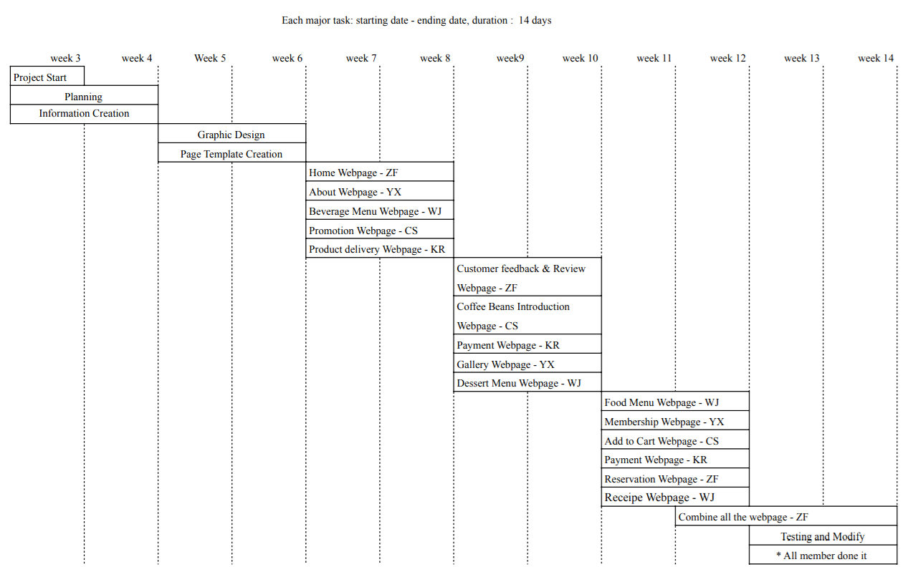

We used 84 days to complete the website

**Group Member**

1 Lim Zhen Foo - ZF

2 Lim Wen Jing - WJ

3 Lim Chiang Shen - CS

4 Ko Yun Xuan - YX

5 Tai Kim Ruey - KR

**Functions or Modules in 3L’s Cafe Website**

1. **Home Page**

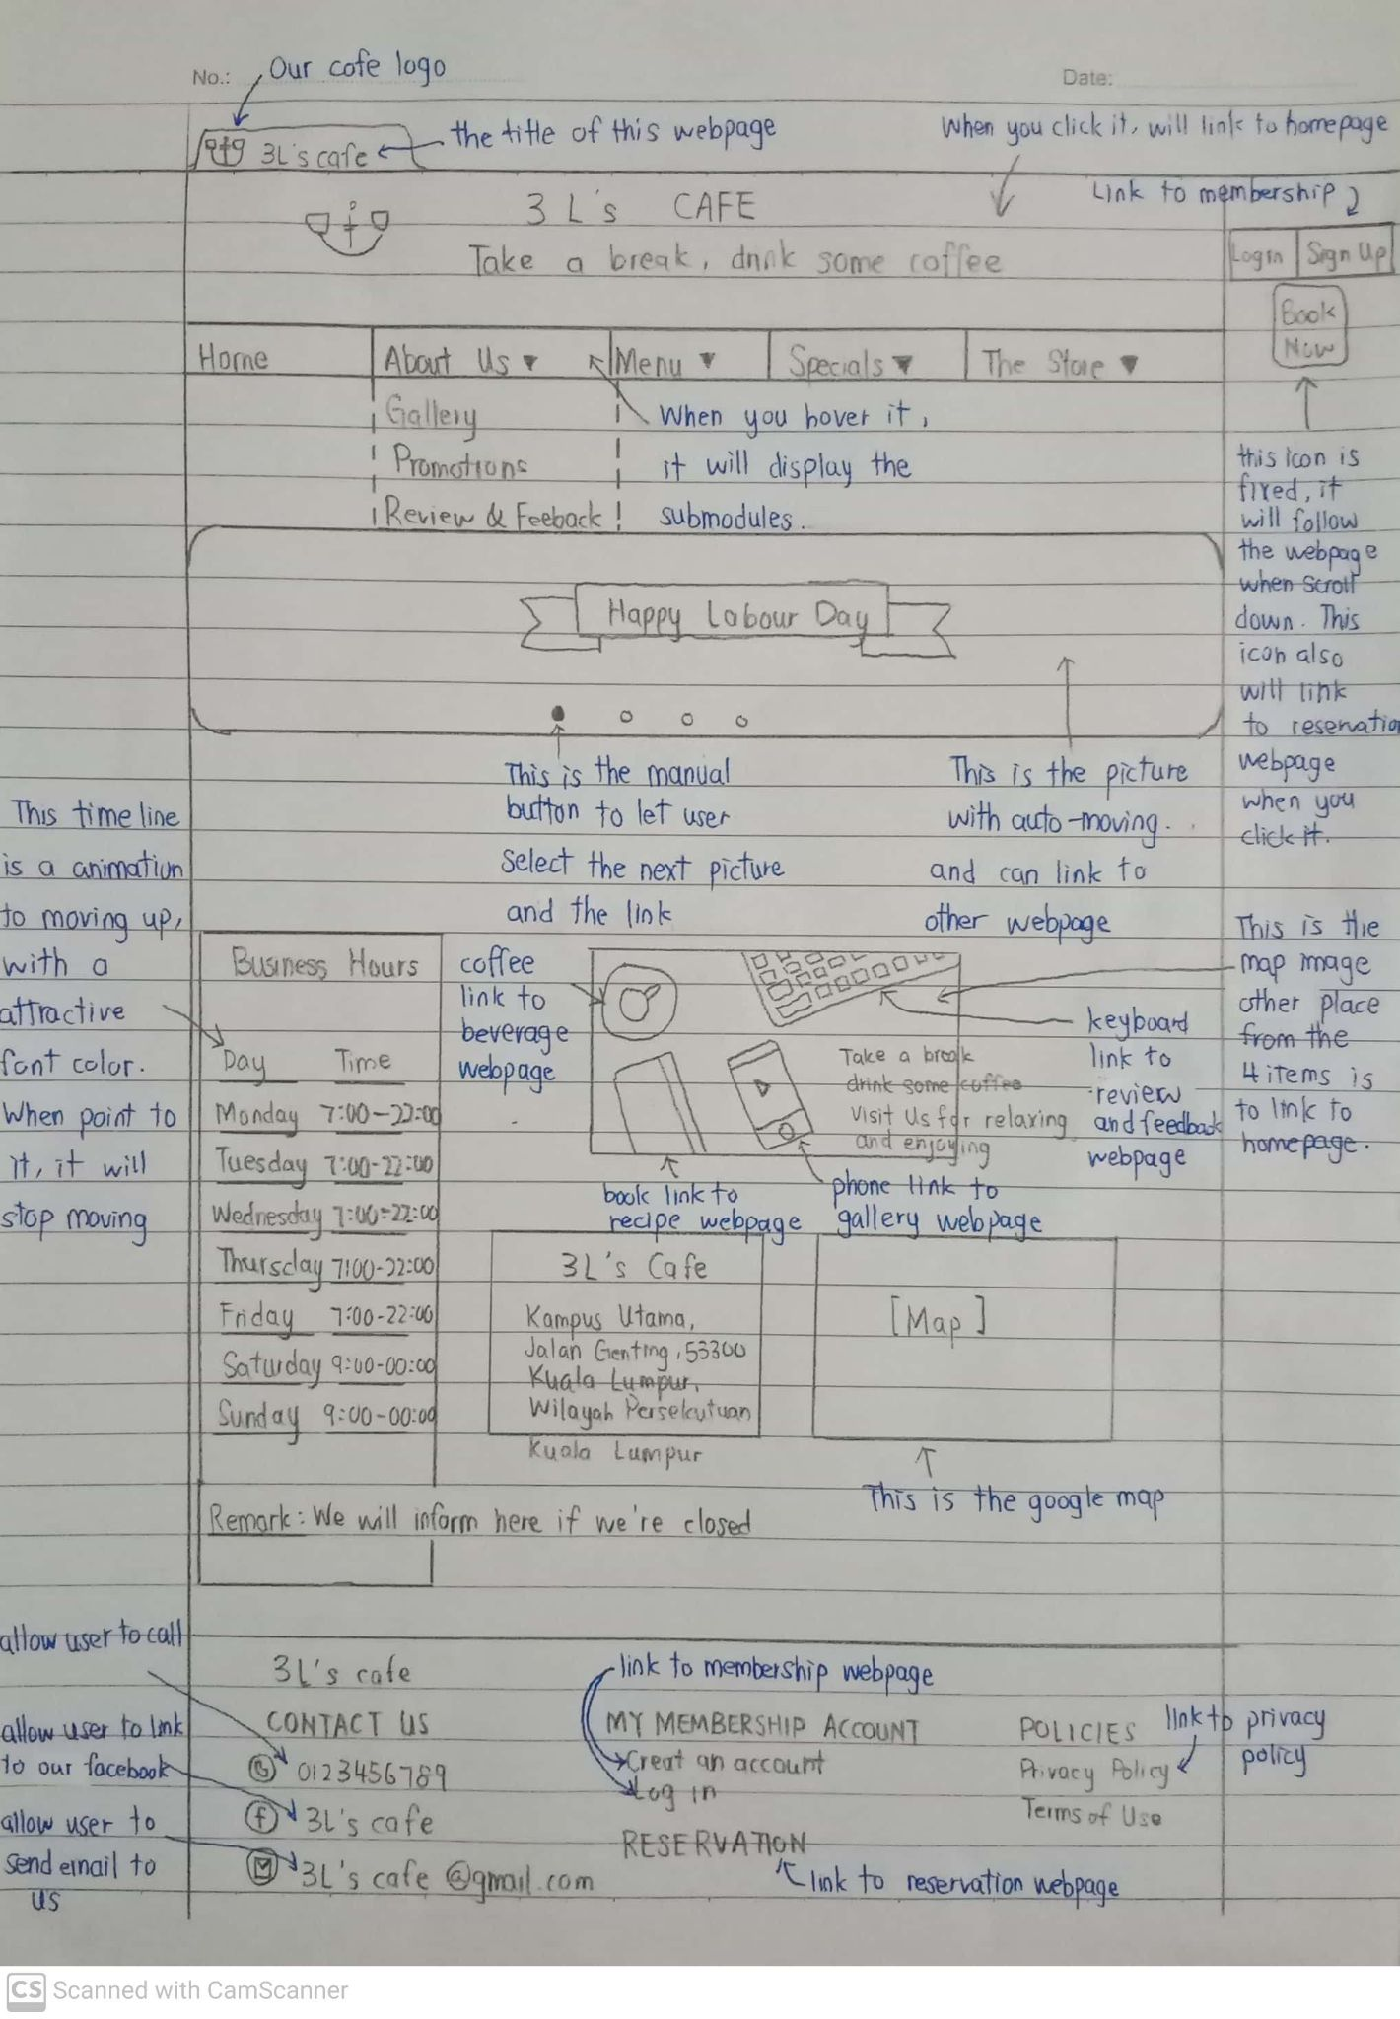

The picture above is showing the home page of the 3L’s cafe. This home page consists of a title, header, slideshow, business hour, an image with hotspot and the slogan, an address with a google map location and the footer. At the top of the webpage, our logo is attached for good-looking and the title with “3L’s Cafe” showing that this is our homepage. I decorate the homepage background with a modern design and put a matchable colour inside the body section.

We design a banner and put it at the top and it’s a hyperlink that can link to the homepage. We apply it to every webpage to show consistency.

The slideshow’s width fits with the body section to attract the user to see it. Every slideshow is a hypermedia that can link to the other webpage according to the picture in the slideshow. The slideshow is moving automatically and also can manual select with the yellow button.

The purpose of the business hour table on the left-hand side is to let the user know our business hour. The business hour section with a black colour background but with attractive font colour. The business hours is an animation that keeps moving up within 25 seconds. When the user hovers on the business hours section, it will stop moving to let the user see the details clearly.

The image with the hotspot is convenient for the user to link to other webpages with a one-click. I also added our slogan “Take a break, drink some coffee Visit us for relaxing and enjoying” to attract the user to consume in our cafe.

In the location part, “3L’s Cafe” with a proper heading and good margin to make a comfortable view. The google map makes it convenient for the user to know the exact location of our cafe. Every section is having a proper distance to show the sense of space so the user won’t be distracted.

In addition, I also create an icon with hyperlinks to the reservation webpage and it’s fixed on the right-top corner of the webpage. When the webpage scroll down, it will follow the webpage to let the user always notice the icon. I also apply it to every webpage to let the user know we have the reservation section.

In the footer part, I also make the colour from light to dark to state out this is the bottom part of the whole webpage. Inside the footer part, there are some hypertexts that can link to another webpage. For example, “Create an account” and “Log in” can link to the member webpage. Besides, the user also can contact us via the telephone icon and the hyperlink, facebook icon and the hyperlink and the email icon and the hyperlink. I apply this footer to every webpage to show the consistency.

1. **Review & Feedback**

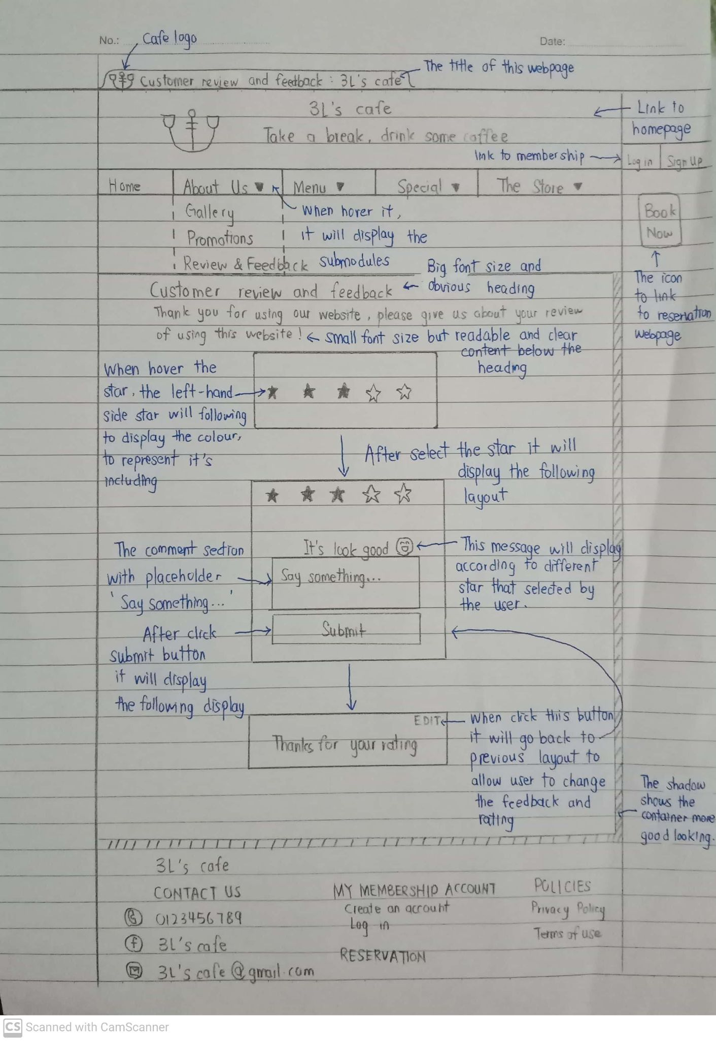

The image above is showing the customer review and feedback webpage. This webpage consists of a cafe logo and title at the top of the webpage, header with our logo, navigation list that links to other webpages, proper heading and its content, rating box and the footer.

The body section, I decorate it with a matchable colour with the whole webpage to show the consistency and also decorate it with a shadow at the right-hand side and bottom side.

At the beginning of the body section, a heading and a paragraph is displayed. I decorate the heading with a big font size to let the user know what is contained in this webpage. Besides, the text also applied with a proper format to show a clear view.

The rating section, I decorate it with a comfortable colour to prevent the user viewing the web page with dissatisfaction. When the user selects the rating stars, the following left-hand side stars will follow to turn up their colour. When the user clicks the star as a submission, it will display the following layout, comment section.

The following layout will display a message according to the amount of stars that was selected by the user. The comment section displayed with a proper distance from the layout to prevent narrow layout. The comment section also displays a placeholder “Say something…” to prompt the user to comment some feedback to us.

After click submit, a message “Thanks for rating” inside a block will be displayed. In addition, the EDIT allows the user to correct their rating and rewrite their feedback.

1. **Reservation**

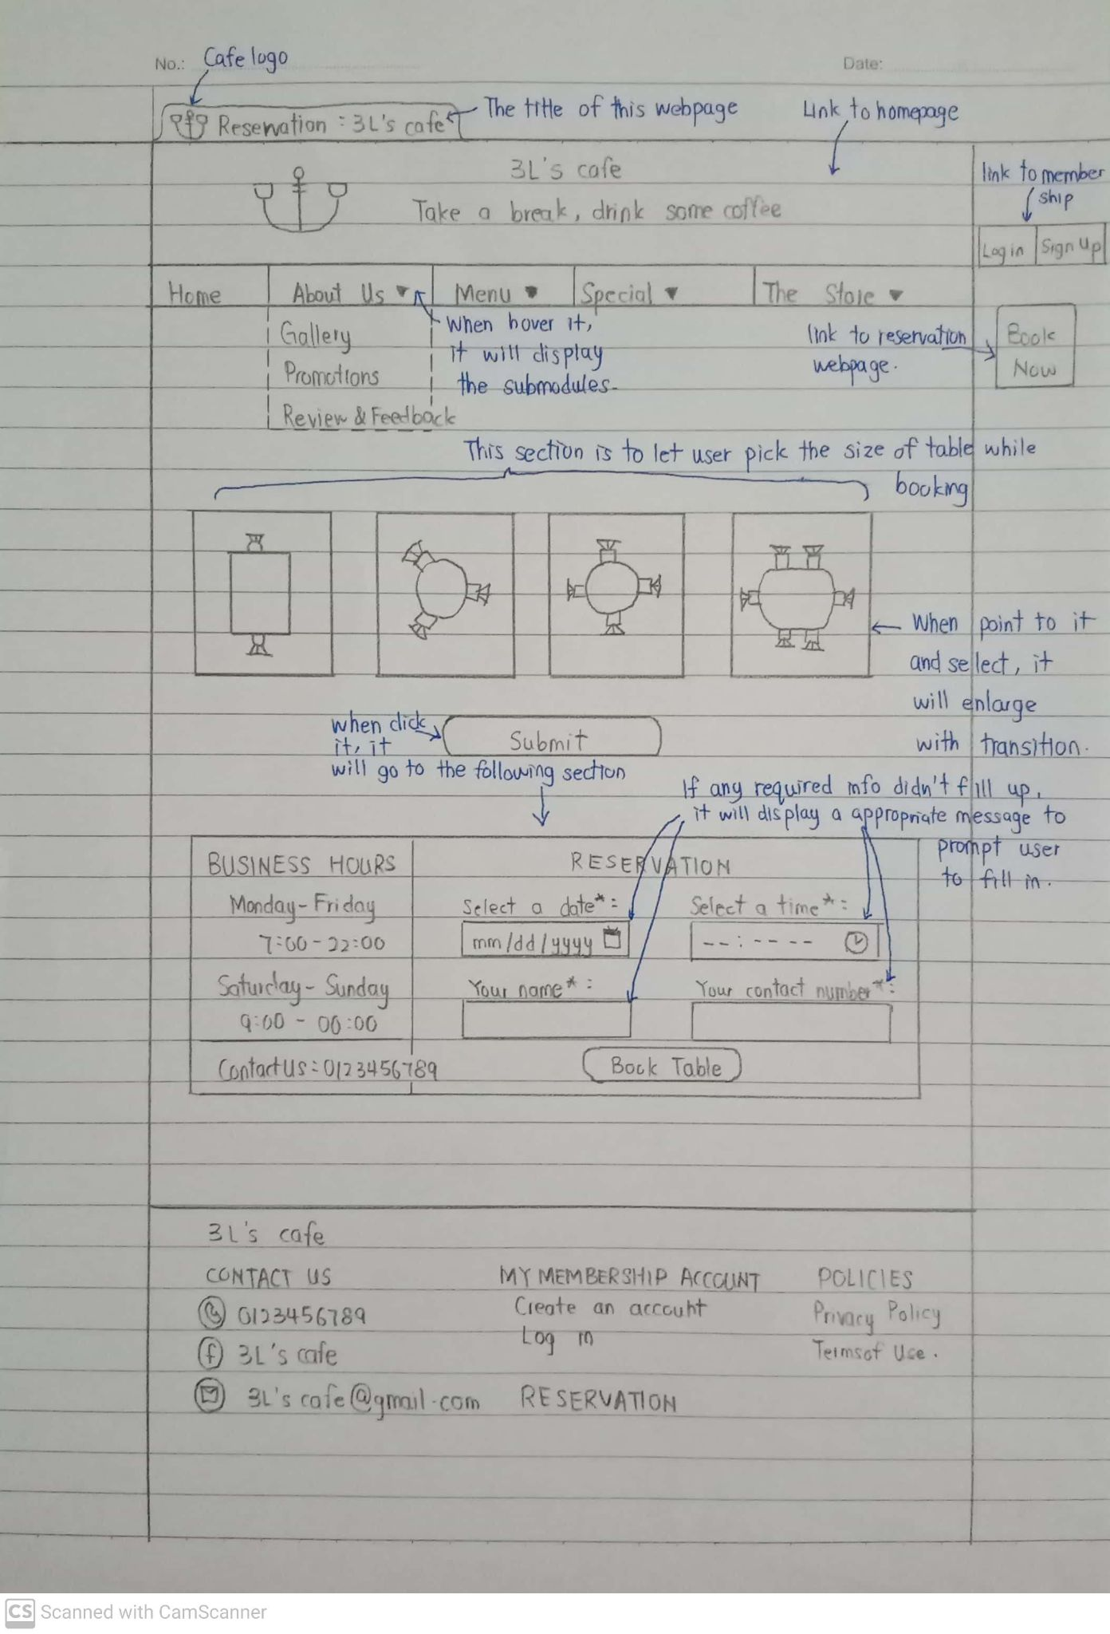

The image above is showing the reservation webpage. This webpage consists of our cafe logo and the title of this webpage, header with our logo, navigation bar that links to other webpage, the table selection section, form of booking and the footer.

For the body section, I selected the background colour with a light blue colour so that can match with the footer and the whole webpage.

The table selection section includes 4 pictures as a button so that the user can select the picture according to the number of people and the submit button. When the user hover or select the picture, the picture will enlarge with a transition. The purpose is to indicate that the picture was selected by the user more obviously.

After the user click the submit button, it will display the form to book the table. In the form, it consists of the business hours and the information part. The design of the business hours is the same as the homepage to show the consistency purpose to prevent the user distraction. The word, “BUSINESS HOURS” I decorate it with all uppercase with a big font size and bolded to show that this is the title. The day and time I decorate it with an attractive colour so that the user can see it clearly.

For the form of the reservation, I put the word, “RESERVATION” as a heading that is the same size as “BUSINESS HOURS”. Inside the form, I required 4 information from the user. If any one of the fields did not fill up and click the “book table” button, it will display the required message on the field that did not fill up. The “book table” button, I design it with a different colour when hovering it to show that the user is ready to submit the form.

**4.1 Food Menu**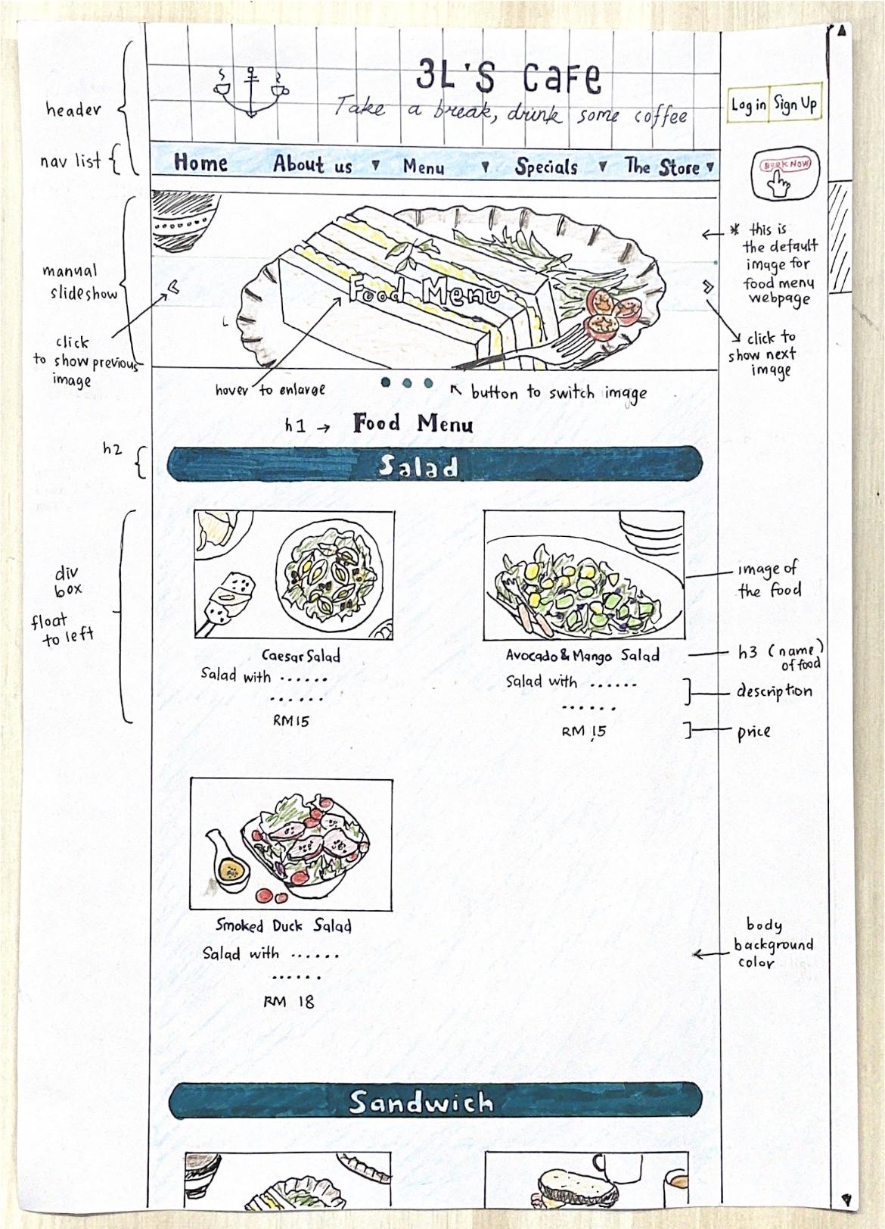

**Function:**

This food menu webpage is to show the food menu selling in the our cafe. The food menu is categorised to salad, sandwich, soup, pasta, rice bowl, and snacks for easy viewing. The food menu will also show images, description, and the price for each food to let the customers know more details about the food.

**Design:**

The header part will display the logo and name of our cafe, then followed by a horizontal navigation bar that can link to different webpages. The navigation bar has a background color of lightblue, while the font color is set to dark blue. When hover on the navigation bar, the hidden dropdown navigation list will be displayed. The body background color is a very light blue color. Down the navigation bar, there will be a slideshow box which is showing different images with different link, which is food menu, beverage menu, and dessert menu. For this food menu webpage, the default image shown at the slideshow box is egg mayo sandwich with a link connected to food menu webpage. When hover on the link, the background color of the link on the image will be changed from lightblue to white color, while the font-color will be changed from white color to dark greenish blue color, and the font-size will be enlarged. After the slideshow, the name of the webpage which is “Food Menu” will be display as heading 1, with dark blue color. Then, it is followed by heading 2 which is the categories of the food, the background color for this is set to dark greenish-blue color, while the font color is set to a very light blue color. Below each categories (h2), the image, name, description, and price of each food will be displayed as a box, and each box is float to the left. The name of food is heading 3 with a dark blue font color. When scroll down to the bottom of the webpage, there is a footer (not shown in drawing) containing the phone number, email, facebook page of our cafe, links to create and sign in account, and terms of privacy and policy. While for the printing layout, the header, navigation bar, slideshow and footer will not be printed. Only the categories, name, description, price and image of the food will be printed, and there is a page break after each categories for easy viewing.

**4.2 Beverage Menu**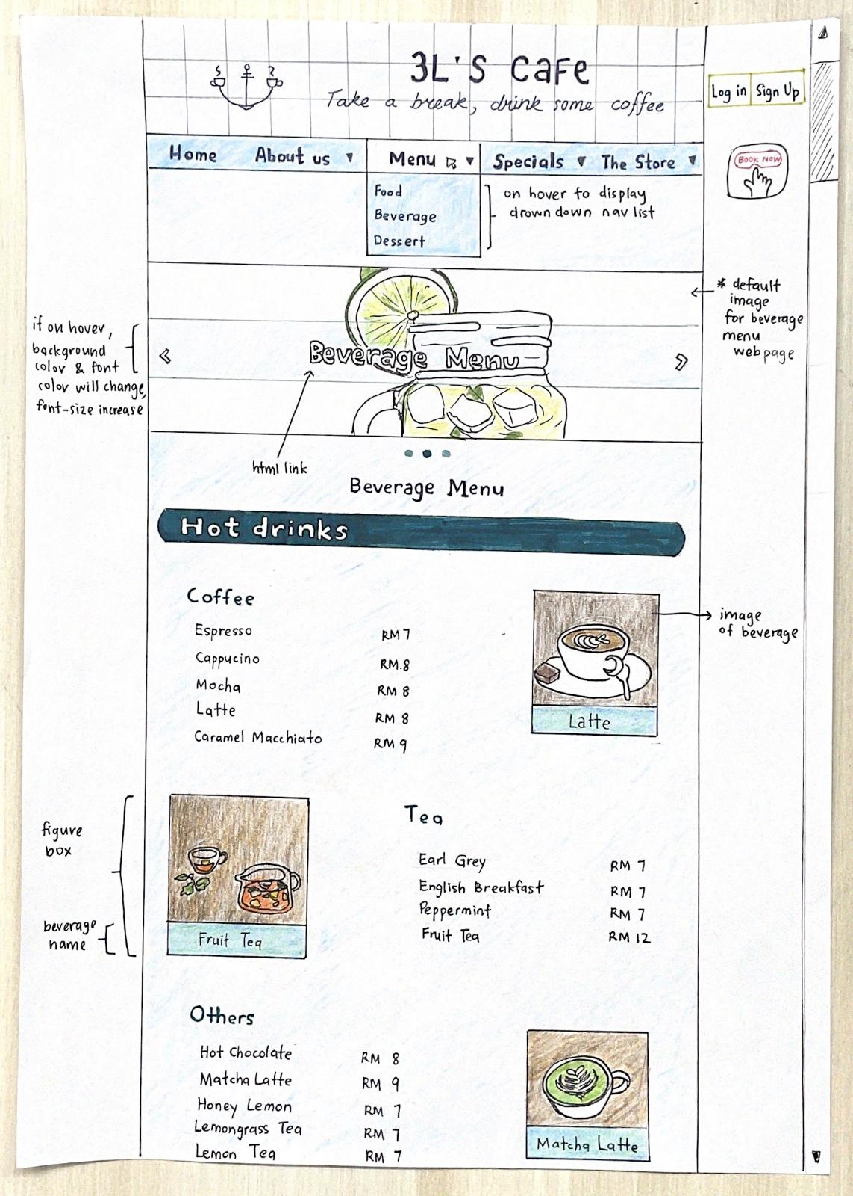

**Functions:**

This beverage menu webpage is to show the list of beverage selling in our cafe. The beverage menu is categorised to two main categories which are hot drinks and cold drinks. For hot drinks, there are 3 sub-categories, which are coffee, tea, and others. As for cold drinks, there are 5 sub-categories, which are iced-coffee, non-coffee drinks, smoothies, fresh juice, sparkling drinks, and others. This menu will show the price of every beverage, and only selected images of beverage will be displayed.

**Design:**

Same as food menu webpage, there is a header shows the logo and name of the cafe, and a navigation bar with dropdown list when on hover. When the mouse is hover on the navigation list as shown in figure above, the element below will also move downwards. For this beverage menu webpage, the default image shown in the slideshow is image of mojito. There is also a link on the image to link to other website accordingly. Below the slideshow, the name of the webpage which is “Beverage Menu” will be display as heading 1, with dark blue color. Then, it is followed by heading 2 which is used to indicate the two main categories “Hot drinks” and “Iced drinks”. Below each categories (h2), there is the sub-categories as heading 3 which indicates the type of the drinks. The font-color for h3 is set to greenish-blue. Each sub-category is display as a box, containing the list of drinks and the price. Beside the sub-category box, there will be a figure box showing the image and caption of one drink. The background-color for the caption is set to greenish-blue color while the font color is white color. When hover on the figure box, the size of the image and the caption will be enlarged. When scroll down to the bottom of the webpage, there is a footer (not shown in drawing) containing the phone number, email, facebook page of our cafe, links to create and sign in account, and terms of privacy and policy. For printing version, the header, navigation bar, slideshow, and footer will not be printed. Only the categories, name, price, image and caption of the beverage will be printed.

**4.3 Dessert menu**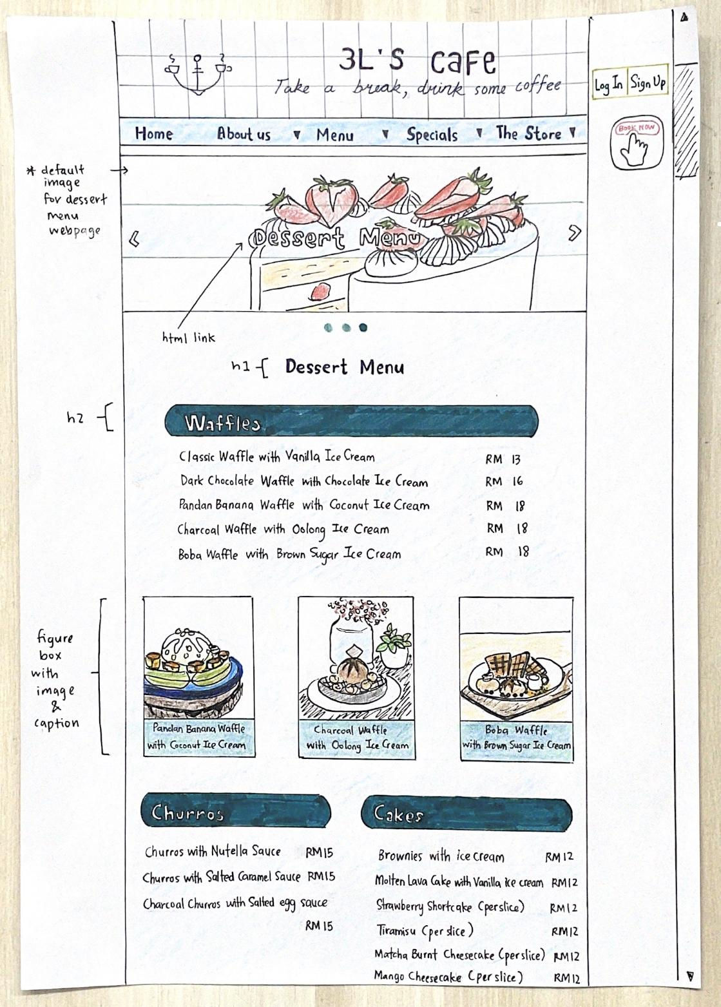

**Functions:**

This dessert menu webpage is to show the list of dessert selling in our cafe. The dessert menu is categorised to 4 main categories which are waffles, churros, cakes, and others. This menu will show the price of every dessert, and will display images for some selected desserts.

**Designs:**

Same as beverage website, the top of this dessert webpage is the header with cafe’s logo and name, followed by a horizontal navigation bar. The default image shown in this beverage webpage is a strawberry shortcake image. The name of this webpage, “Dessert Menu”, is displayed as heading 1. The three categories of dessert is displayed as heading 2, with a dark greenish-blue background color and a white font color. Each category is a box containing the name of the dessert and their price. At the bottom part of each category, there are some images of the dessert will be shown with captions. The background-color for the caption is greenish-blue color. When scroll down to the bottom of the webpage, there is a footer (not shown in drawing) containing the phone number, email, facebook page of our cafe, links to create and sign in account, and terms of privacy and policy. For printing version, the header, navigation bar, slideshow, and footer will not be printed. Only the categories, name, description, price, image and caption of the dessert will be printed.

**5. Recipe**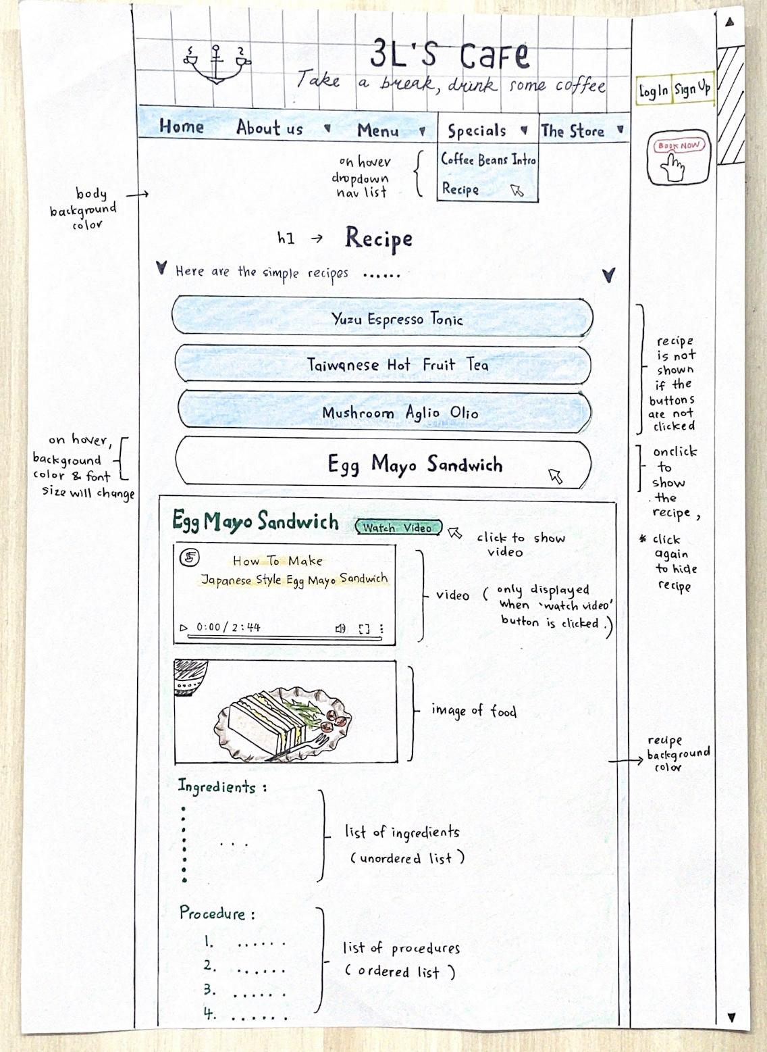

**Function:**

This recipe webpage will share the recipes for some of the popular selling products in our cafe. For now, there are only 4 recipes shared in this webpage, which are yuzu espresso tonic, taiwanese hot fruit tea, mushroom aglio olio, and egg mayo sandwich. Each recipe is included with the list of ingredients, procedures and video, so that the recipe is more understandable by the customers.

**Design:**

The header part is the cafe’s name and cafe’s logo, and a horizontal navigation bar. This recipe webpage can be access from the dropdown navigation list under “Specials” when it is on hover. The body background color of this webpage is a very light blue colour same as the menu webpages. The name of this webpage which is “Recipe” is displayed as heading 1, which the style is also same as the menu webpages. There is four buttons with javascript which each links to different recipe. The background-color of the button is lightblue color while the font-color is dark blue colour. When the button is on hover, the font-size and size of the button will be enlarged and the background-color will change to lighter blue color which is almost looks like white color. When the button is on click by user, the hidden recipe will be shown. down the button. The content of the recipe has a light tiffany blue background color while the font-color for the name of the recipe, the word “Ingredients” and “Procedures” is green color. There is a “Watch Video” button beside the recipe’s name. When user click on the button, the hidden video will be displayed down the name of the recipe. The video includes the captions with white font color and orange background color. Besides that, the image of food is shown in the content of the recipe, followed by list of ingredients and procedures. The ingredients list is an unordered list, while the procedures is an ordered list. To hide the content of the recipe, just click the button on top of the content again. The same way also can work with the “Watch Video” button to hide the video. When scroll down to the bottom of the webpage, there is a footer (not shown in drawing) containing the phone number, email, facebook page of our cafe, links to create and sign in account, and terms of privacy and policy. For printing version, the header, navigation bar, video and footer will not be printed. All the recipes will be printed out directly with a page break after each recipe.

**6. Promotions**

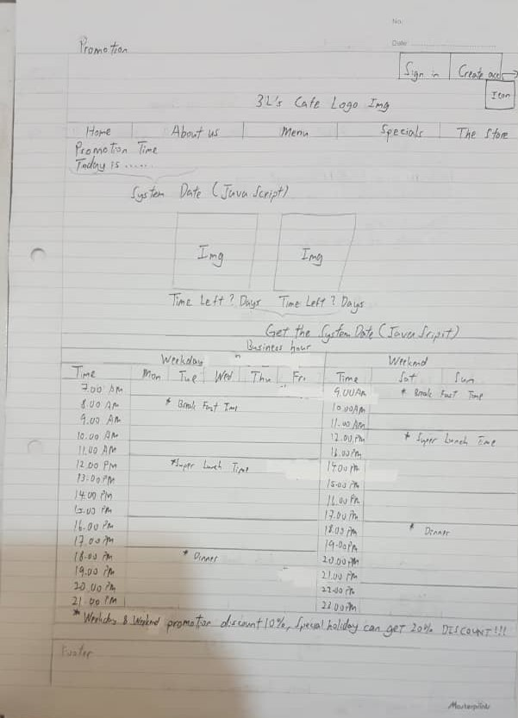

This module is a promotion. It will record when our store has a promotion date and time. For example, how many days are there between today and Labor Day on May 1, and there are specific promotional periods on normal working days. For example, breakfast is from 7:30 to 9:30, customers can enjoy a 10% discount. If it is a special event or holiday, the discount can be up to 20%.

**7. Coffee Beans Intro**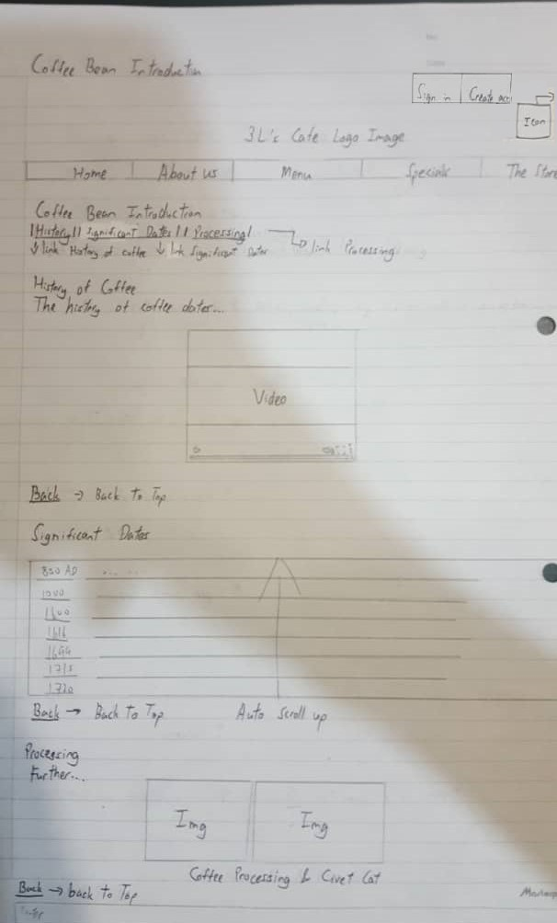

This module is "Introduction to Coffee Beans". It will briefly explain the history of coffee. In addition, you can also play the video in it to get a deeper understanding of the history of coffee. The next part is the significant dates of coffee. I use an automatic loop to play the significant dates of coffee all the time. If the customer wants to see it more clearly, he will stop it as long as the mouse is placed in the table. The last part is coffee processing, which introduces the steps of coffee processing and the cute civet cat.

**8. Add To Cart**

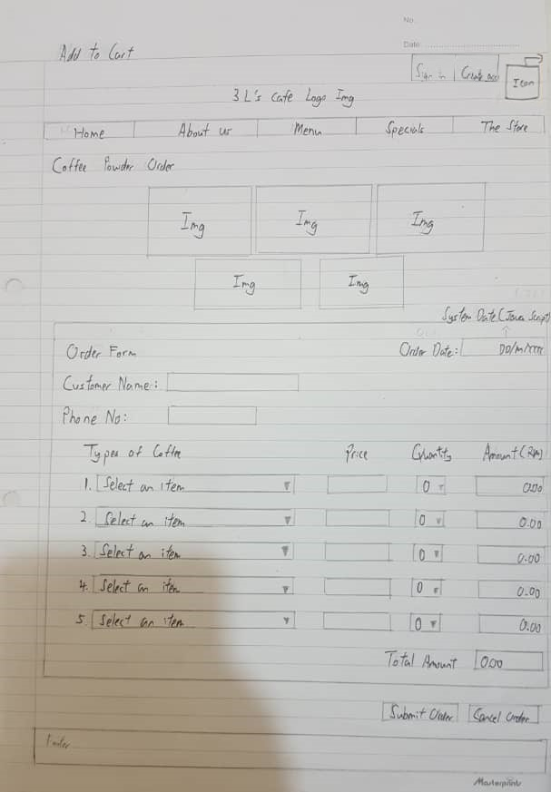

This module is Add to Cart. We will sell coffee powder on this page because the coffee in our restaurant has always been very popular. We will sell the coffee powder we use in order to allow customers to enjoy a cup of delicious coffee at home. First enter this page and you will see 5 kinds of coffee powder are Instant Coffee Classico Taste, Ground Espresso Classico Coffee, Ground Moka Classico Coffee, Ground Espresso Intenso Coffee Dark Roast and Ground Decaffeinated Coffee (Each can has a weight of 250 grams). If you want to order, you must fill in the customer name and phone number. After that, you can choose the coffee powder you want to choose. After you choose the coffee powder, the price will automatically appear. You can then select the quantity, which will be displayed in the "Amount". You can choose to change the quantity of the product, after which the system will automatically calculate the total price. If you want to choose the second coffee powder, the operation is the same as above. If you think 2 types are enough, please submit your order, or you can cancel the order, and we will prepare the coffee powder you need within 3 days.

**9. About Us**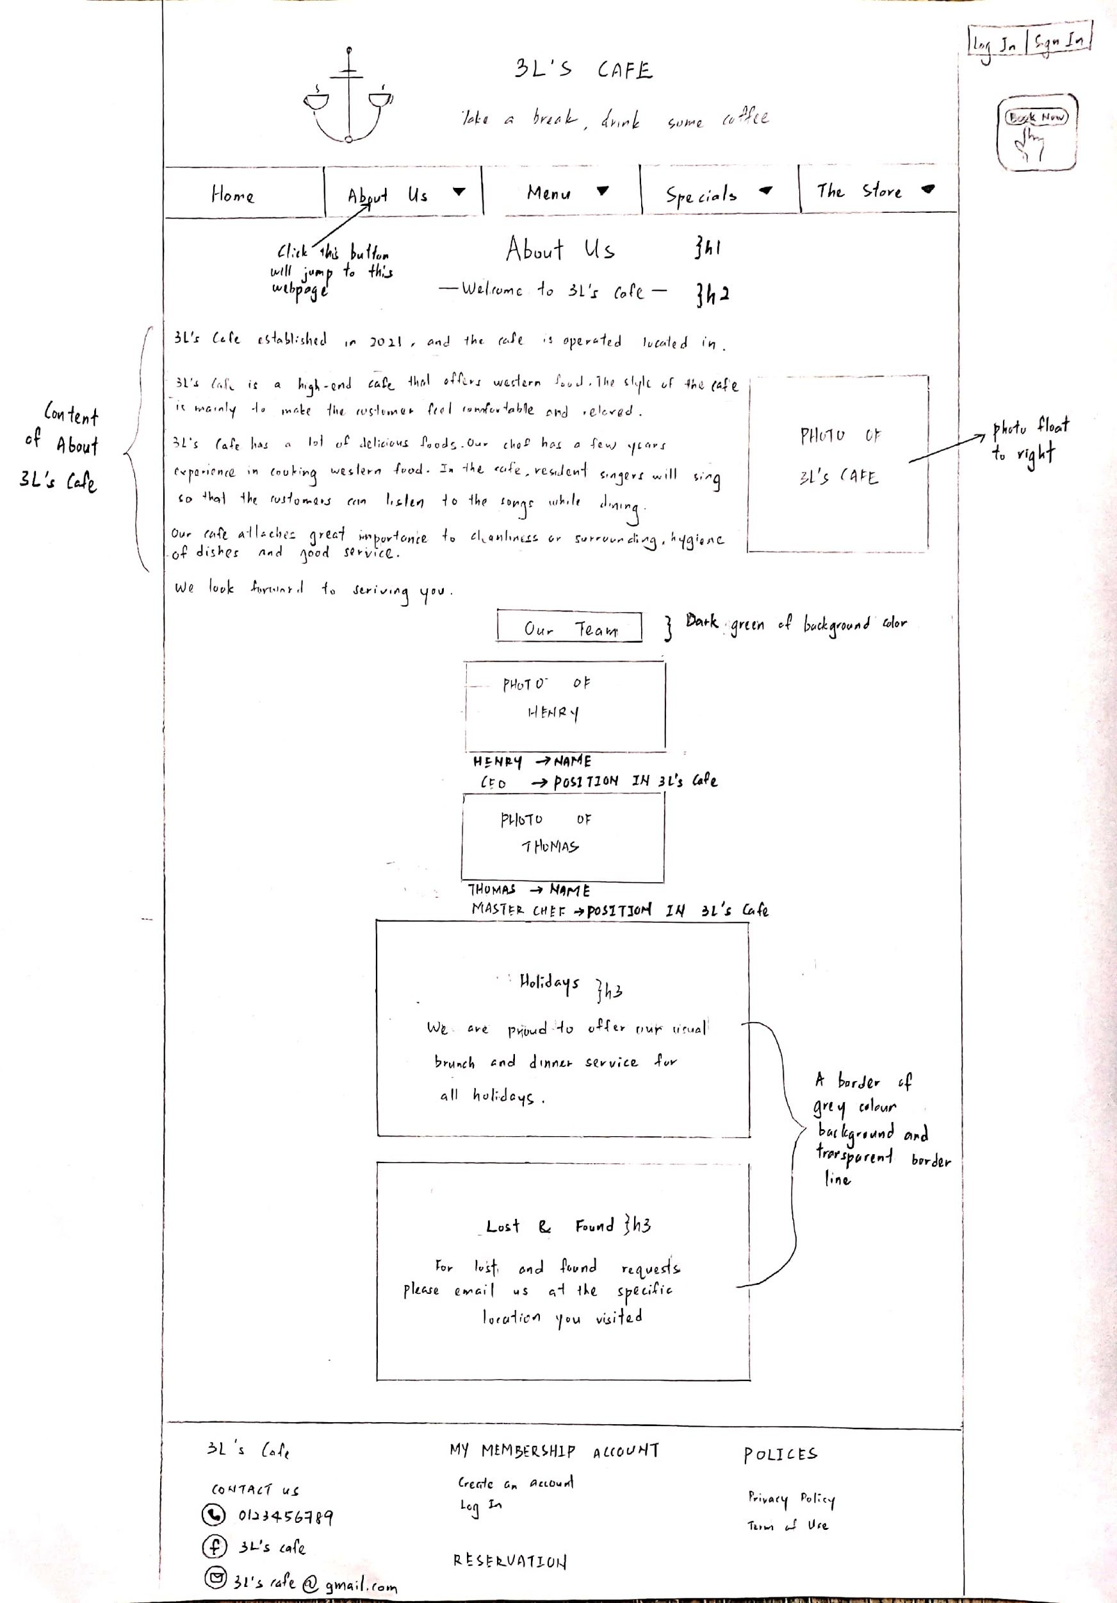

This webpage shows the module of About Us. This about us webpage will present when pressed on the button “About us” of the navigation bar in the header. This module is to help people to know about 3L’s Cafe like its history and purpose.

On the top of this webpage will show the logo and the name of 3L’s Cafe. Below it is the navigation bar that has included “Home”, “About Us”, “Menu”, “Specials” and “The Store”. The main background is filled up with light green colour. Then follow that is the topic of the webpage which is “About Us”. Next, I put the description of 3L’s cafe in a test by a few paragraphs and put a picture of the cafe beside it by floating the picture to the right.

Then, the next part is to introduce the team in the 3L’s Cafe. I decorate the Subtopic of “Our Team” by h4 and put the dark green background for it. Below, I put the photo of staff of the cafe that are located in the center of the web page and followed by their name in bold and the position in 3L’s Cafe.

Then at the bottom of the webpage will briefly explain the flow of 3L’s Cafe during holidays and what customers can do when they are lost or found in the cafe. I decorate them with two borders with a background colour of light grey. One of the borders, the word “Holiday” is in style h3 and below it is its content. The decoration of the second border and the style of text for “Lost & Found” is the same with the first border.

**10. Gallery**

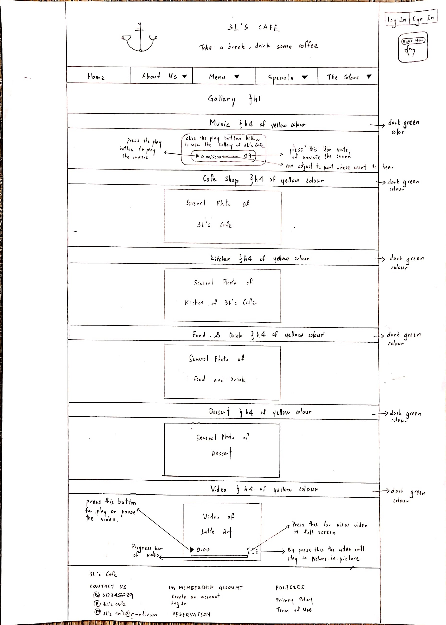

The photo above roughly shows the whole webpage of the Gallery module. On the top of this webpage is the logo and the name of the cafe. Below it is the navigation bar that has included “Home”, “About Us”, “Menu”, “Specials” and “The Store”. The main background is filled up with light green colour. When the user moves the mouse to the option of “About Us”, then it will show a drown down list that contains “Gallery”, “Promotions” and “Review & Feedback”, on the navigation bar. When clicking the “Gallery”, it will show the webpage show in picture.

The main topic is the “Gallery” with dark green font. Next, the subtopic is set to show each type of photo of Cafe. I decorate it by putting the background colour to dark green and the colour of the font is yellow. For the first subtopic is “Music”, I put an audio which is 5 minutes of music below it for the user to have more feeling about the cafe when watching the gallery. I decorate the audio in a border that is background with yellow colour, border line with orange colour and type the instruction on the audio with font gold colour. Then, the second subtopic is Cafe, and followed after that is “Kitchen”, “Food & Drink” and “Dessert”, below these subtopic are all the photos that are about the subtopic. The last part of this webpage is a video of Latte Art. All of this audio, photos and video are put at the center of the webpage.

**11. Membership Account**

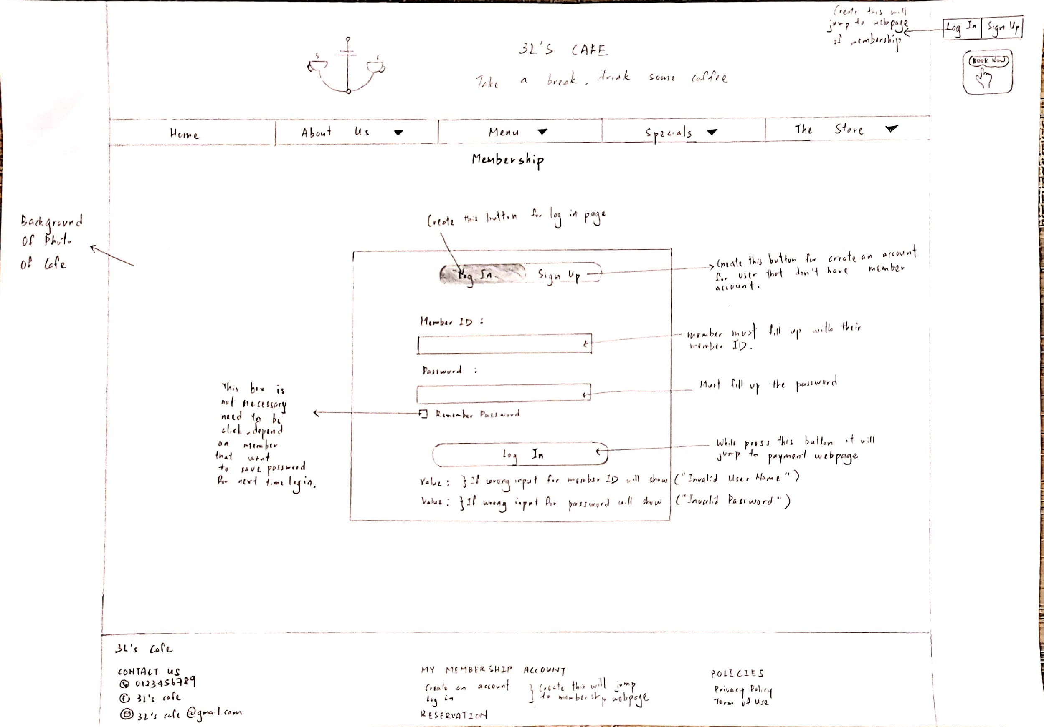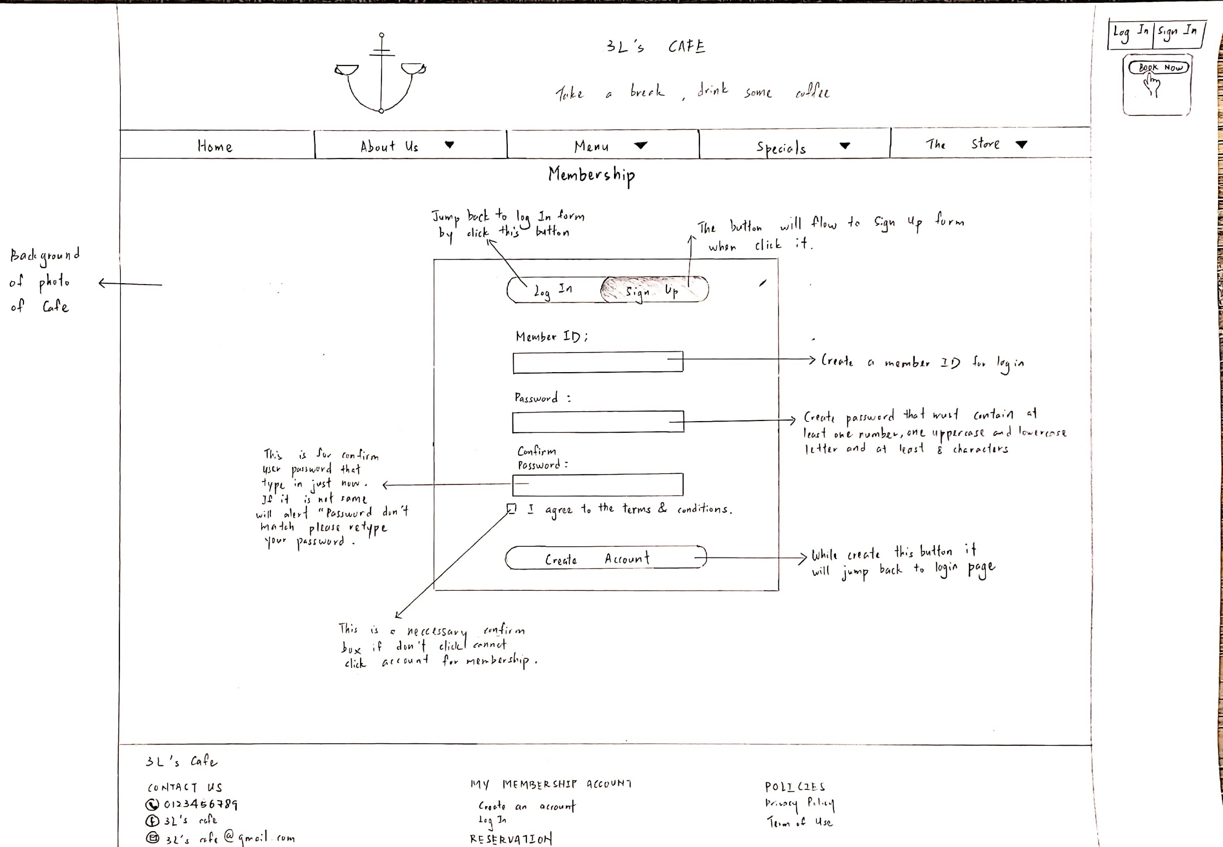

The photos above show the module of membership which is login page and sign up page. This will show when clicking on the membership footer or clicking on the button that is placed at the upper right corner of the webpage which will be present at all web pages.

The top of this webpage is the logo and name of the cafe. Follow that is the navigation bar. First, I set a photo of the cafe as the background of the webpage. Then, I click a form and decorate it to the center of the webpage with a white background colour. Then, I set two buttons (log in, sign up) in a button box at the upper of the form. The button box is decorated by a box shadow of blue colour while the toggle button by two mix colours that are green and purple colour. Following that, I set the input form for members to input ID and password. And click a checkbox for users that want to remember their password. Then, the login button is created. I set the right member ID and Password is {lalala, 1234}, if it is input wrongly, It will display an invalid message in the value part. For the input form, all are required to fill up, if don’t it will not be able to login. Last, when the login button is clicked it will jump to the payment webpage.

When the user clicks the sign up button, the toggle button will flow to it. And the login form will flow to the left and the sign up form will present in the form box. That is a few input boxes for users to create their member ID and password. All of the input boxes are required to fill up and cannot leave space on there. For input password, it must contain at least one number, one uppercase and lowercase letter and at least 8 characters. If not, the password cannot be created. The next input box is for users to confirm their password. If it is not the same with the password type just now, the webpage will present an alert message that is “Password don’t match please retype your Password”. Then, I put a checkbox for users to agree with the terms and conditions, this is a required checkbox. The account will not be created if the checkbox doesn't have a click. After filling up all the input and checkbox, when the user clicks on the create account button it will jump to the login page for the user to log in.

**12. Delivery**

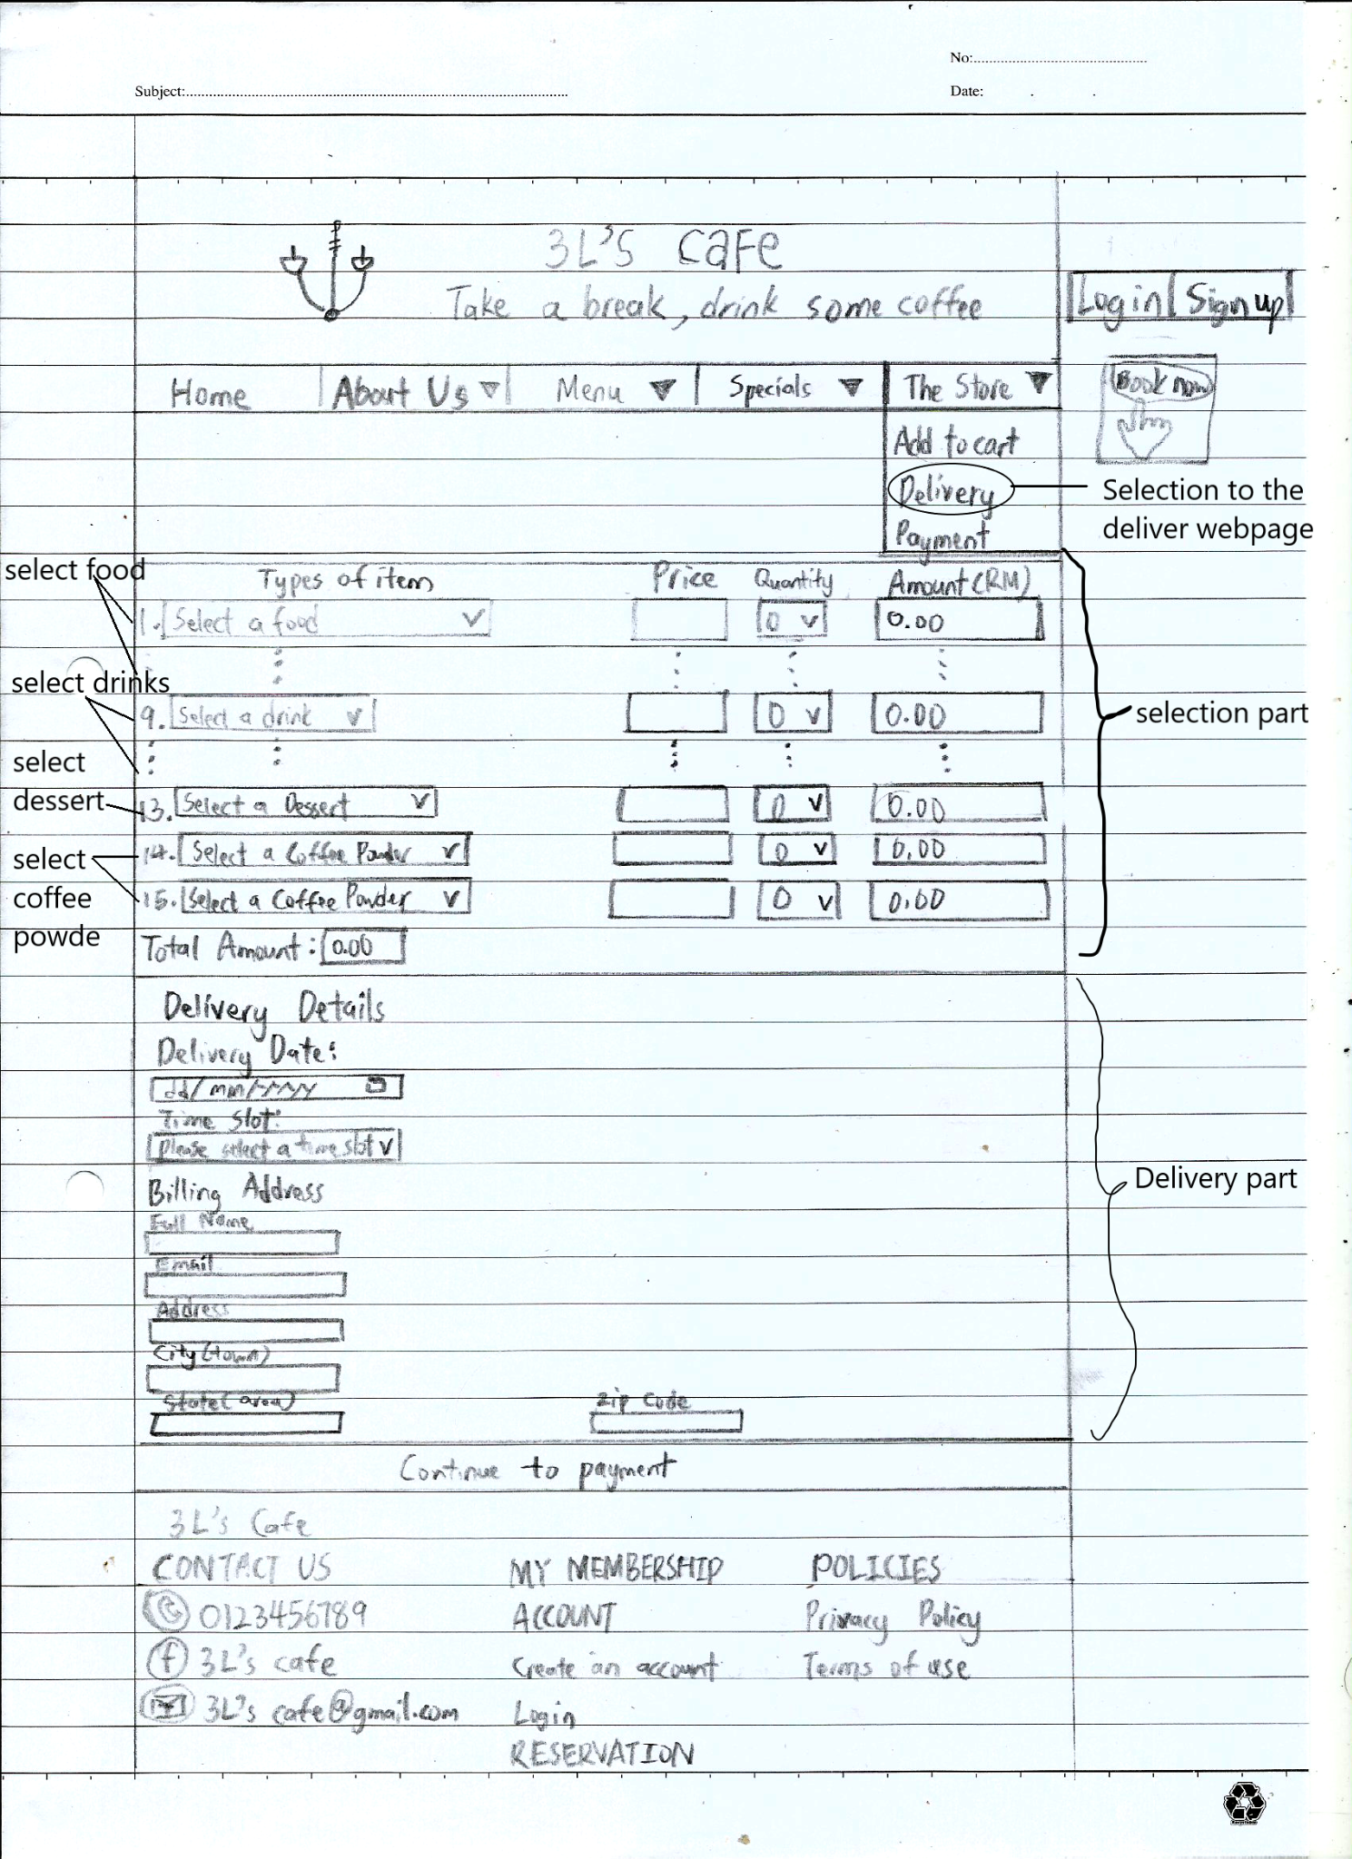

The picture above shows the Product Delivery Menu. First of all, when the user clicks at the header button of delivery in the group of The Store. The user will jump into the webpage show at the about. In the diagram, we can see that the product delivery webpage has 2 sections.

In the beginning part of the delivery webpage, users can select the item they want to order. The selection of items we can separate into 4 categories. In category one, users can select the food of items they want to buy from the 1st line until 8th line. In category two, users can select the drinks from the 9th line until 12th line. In category three, users can select the Dessert in line 13. At the last of the selection categories, users can choose the coffee powder in at the end two lines of selection.

In this selection part, users only need to select the item they want to order only. User no need to fill up all the selection. After users select the item, the system will continue to ask the user to key in the quantities they want to order. In the Selection part, users can see the price per each selection item when the users select that item. After the users fill up quantities, systems will calculate out the amount of the item. After users select completely to do the order, the system will calculate the total amount at the of the selection part.

After the selection part is completed, users will come into the delivery part. In this starting point of the part, users will be required to choose the date the users want to get delivery, choose the time slot of the cafe provided, and write down details of the billing address to give the deliverator to send the order.

In the billing address, there are required full names of the users, still valid the email address to easily the deliverator to confirm the order with the customers, home addresses, city, state, and zip code. If this part, the system has to do the validation for each section to make sure that the user will fill in correctly.

In the full name part, users only can type the alphabet. If the users type in other letters such as’-’, ‘=’, ‘2’, ‘.’ and the other letter, the system will come out invalid format message. In the email address, users must follow the format ‘[xxx@xxx.xxx](mailto:xxx@xxx.xxx)’. In the home addresses part, users need to type in the correct address, users can not be blank in that part. In parts of the city, users only can fill in the alphabet. In the Zip Code part, users only can key in 5 digit of the number. Lastly, in part of the state, users only can fill in the alphabet.

After completing all the things required at the above, the users can click the button below to jump to the payment.

**13. Payment**

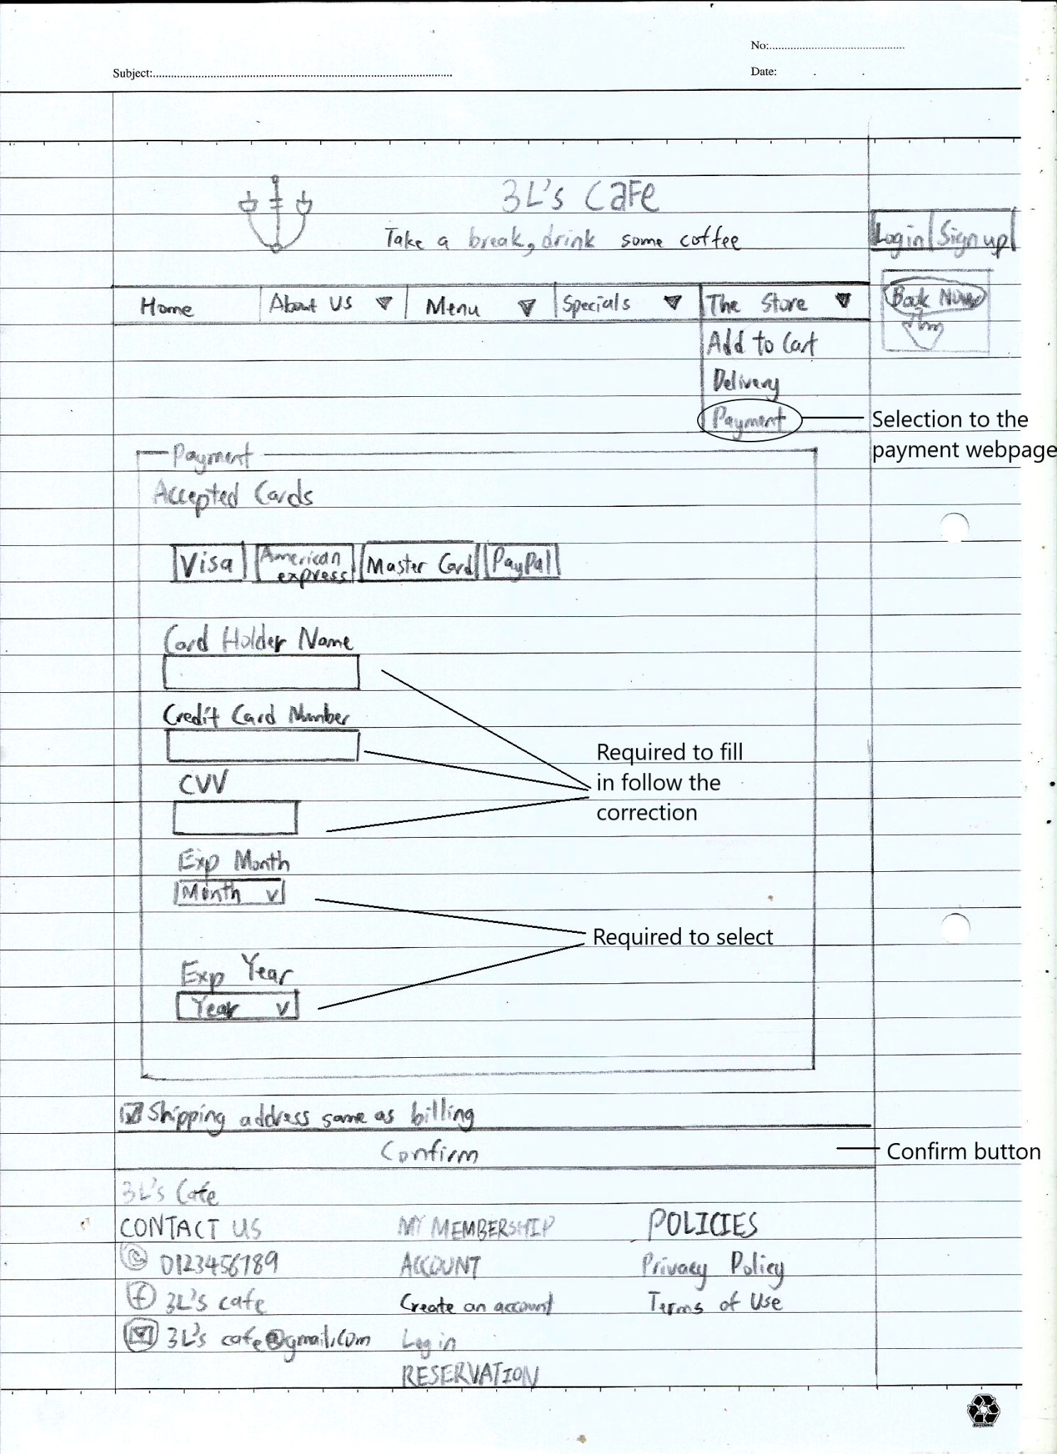

In this system, we got the 2 ways to the payment method. The first way is users can after the delivery order to directly jump into the payment. Another way is the users can click the button of the payment in categories of The Store to jump into the payment method.

In our webpage, we only prepare the way of payment by the credit card only. The diagram above shows the payment accepted by card. The users required to fill in the CardHolder Name, Credit Card Number, CVV, Exp Month and Exp Year.

The validation correctly to use for the CardHolder Name is only can use the alphabet. In the Credit Card Number part, users are required to key in 16 digits of number on the credit card without any space, dick, and other letters. In the CVV part, users are required to key in 3 digits of the numbers. In the Exp Month part, users are required to select the expires month of the credit card. The expired month of the credit card is shown at the before part ‘xx/xx’. In the Exp Year part, users are required to select the expired year of the credit card. The expired year of the credit card is shown at the after part ‘xx/xx’. At the below before confirm button, the system will ask users to tick the shipping address same as billing to confirm the shipping address.

After completing all the things required at the above, the users can click the button below to confirm the payment.

**14. Privacy Policy & Terms of Use**

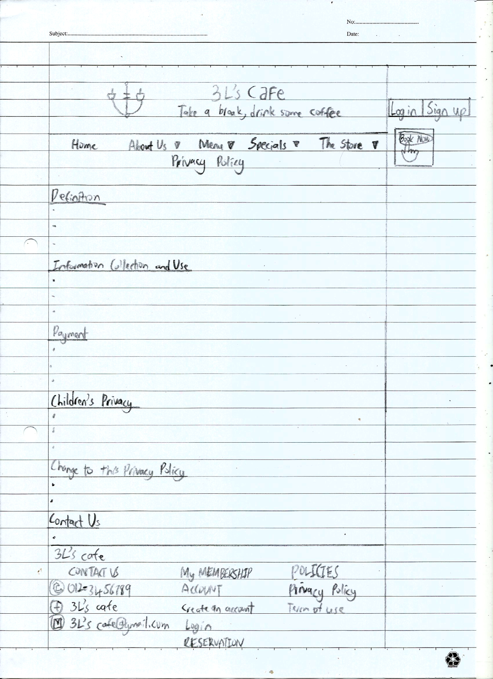

When the users select the privacy policy & Term of use at any foot page of the webpage, the system will jump into the Privacy policy webpage.

The diagram above shows the overview of the webpage. The users can read the privacy policy according to the subtitle given in the webpage. In our Privacy Policy, we included subtitles of Definition, Information Collection and Use, Payment, Children’s Privacy, Change to this Privacy policy and Contact Us.

**References**

1. 2010. *Lettuce, avocado and mango salad*. [image] Available at:

<<https://www.taste.com.au/recipes/lettuce-avocado-mango-salad/eb92f6f3-3125-4bd1-ae24-d19eb7689e38>> [Accessed 20 March 2021].

1. Wongkaew, S., 2019. *Caesar Salad*. [image] Available at: <https://www.thespruceeats.com/caesar-salad-recipe-256363> [Accessed 20 March 2021].
2. My Cafe Restaurant, n.d. *Smoked Duck Salad*. [image] Available at: <<http://homedelivery2u.com/order-categories/product/8615-smoked-duck-salad-%E7%86%8F%E9%B8%AD%E6%B2%99%E6%8B%89-my-cafe-restaurant>> [Accessed 20 March 2021].
3. 2018. *Mushroom soup and garlic bread*. [image] Available at: <https://www.freepik.com/premium-photo/mushroom-soup-garlic-bread_2647965.htm> [Accessed 20 March 2021].
4. Chen, N., 2019. *Japanese Egg Sandwich*. [image] Available at: <<https://www.justonecookbook.com/japanese-egg-sandwich-tamago-sando/>> [Accessed 20 March 2021].
5. Just One CookBook, 2019. *How to Make Japanese Egg Sandwich (Tamago Sando) (Recipe)*. [video] Available at: <<https://www.youtube.com/watch?v=PVN5VurqAxA&t=13s>> [Accessed 25 March 2021].
6. Chen, N., 2019. *Japanese Egg Sandwich (Tamago Sando) たまごサンド • Just One Cookbook*. [online] Just One Cookbook. Available at: <<https://www.justonecookbook.com/japanese-egg-sandwich-tamago-sando/>> [Accessed 20 March 2021].
7. Tesco, n.d. *Avocado and bacon sandwich*. [image] Available at: <<https://realfood.tesco.com/recipes/avocado-and-bacon-sandwich.html>> [Accessed 20 March 2021].
8. Hodges, C., 2020. *Mushroom Pasta with Garlic and Herbs*. [image] Available at: <<https://www.heinens.com/recipes/mushroom-pasta-with-garlic-and-herbs/>> [Accessed 20 March 2021].
9. Me'nate, n.d. *Seafood Aglio e Olio Pasta*. [image] Available at: <<https://menate.com.my/product/seafood-aglio-e-olio-pasta/>> [Accessed 20 March 2021].
10. George, 2020. *Chicken Bolognese*. [image] Available at: <<https://moireslife.com/chicken-bolognese/>> [Accessed 20 March 2021].
11. Mountain, J., n.d. *Spaghetti and Meatballs*. [image] Available at: <<https://www.bbc.co.uk/food/recipes/spaghetti_and_meatballs_69603>> [Accessed 20 March 2021].
12. FIsher, I., n.d. *Spaghetti Carbonara*. [image] Available at: <<https://cooking.nytimes.com/recipes/12965-spaghetti-carbonara>> [Accessed 20 March 2021].
13. Susan, 2016. *Teriyaki Salmon Bowl*. [image] Available at: <<https://www.simplehealthykitchen.com/teriyaki-salmon-bowl/>> [Accessed 20 March 2021].
14. Pieducks Pizza, n.d. *French Fries*. [image] Available at: <<https://pizzaonne.com/product/sides/french-fries/>> [Accessed 20 March 2021].
15. Zoya, 2020. *Korean Fried Chicken*. [image] Available at: <<https://bestinsingapore.com/korean-fried-chicken/>> [Accessed 20 March 2021].
16. Schofield, J., n.d. *Chicken Katsu with Curry Sauce*. [image] Available at: <<http://everydaygourmet.tv/recipes/chicken-katsu-with-curry-sauce/>> [Accessed 20 March 2021].
17. Oyakata, n.d. *Gyudon*. [image] Available at: <<https://www.oyakata.com.pl/en/masters-recipes/gyudon-recipe-for-beef-in-sweet-sauce>> [Accessed 20 March 2021].
18. Warburtons, n.d. *Smoked Salmon and Cream Cheese Thin Bagels*. [image] Available at: <<https://www.warburtons.co.uk/recipes/smoked-salmon-and-cream-cheese-thin-bagels/>> [Accessed 20 March 2021].
19. salewhale, n.d. *Grilled Ham & Cheese Sandwich*. [image] Available at: <<https://www.salewhale.ca/en/recipe/salewhale/37332/grilled-ham-cheese-sandwich-37228>> [Accessed 20 March 2021].
20. Rasa Malaysia, n.d. *Pesto Pasta with Chicken*. [image] Available at: <<https://rasamalaysia.com/pesto-pasta-with-chicken/>> [Accessed 20 March 2021].
21. Hospitality Development Company, n.d. *Cafe Latte*. [image] Available at: <<https://www.hdc-global.com/shop/ancb-all-drinks/cafe-latte-2/>> [Accessed 10 March 2021].
22. Spice Mountain, n.d. *Matcha Latte*. [image] Available at: <<https://www.spicemountain.co.uk/product/matcha-latte/>> [Accessed 10 March 2021].
23. Miam Miam, n.d. *Refreshing Hot Fruit Tea*. [image] Available at: <<https://miam.sg/menus/refreshing-fruit-tea/>> [Accessed 10 March 2021].
24. Michelle, n.d. *Hojicha Latte*. [image] Available at: <<https://thefeedfeed.com/siftandsimmer/hojicha-latte>> [Accessed 10 March 2021].
25. Ventray, n.d. *Avocado Smoothie*. [image] Available at: <<https://www.ventray.com/en-us/recipes/avocado-smoothie>> [Accessed 10 March 2021].
26. 2019. *Yuzu Lemonade*. [image] Available at: <<https://www.tripadvisor.co.nz/LocationPhotoDirectLink-g60763-i406433683-New_York_City_New_York.html>> [Accessed 10 March 2021].
27. Traynor, A., n.d. *Hot Honey Grapefruit Soda*. [image] Available at: <<https://moodypantry.com/blog/hot-honey-grapefruit-soda>> [Accessed 10 March 2021].
28. Mirchi Tales, n.d. *Virgin Mojito Mocktail*. [image] Available at: <<https://www.mirchitales.com/virgin-mojito-mocktail/>> [Accessed 10 March 2021].
29. Omomo Tea Shoppe, n.d. *Grapefruit Green Tea*. [image] Available at: <<https://www.omomoteashoppe.com/drinks/grapefruit-green-tea>> [Accessed 10 March 2021].
30. Williams Sonoma, 2016. *Iced Americano*. [image] Available at: <<https://blog.williams-sonoma.com/cool-brews-make-iced-coffee-at-home/>> [Accessed 10 March 2021].
31. Zhang, C., 2020. *Japanese-Style Strawberry Shortcake*. [image] Available at: <<https://blog.williams-sonoma.com/cool-brews-make-iced-coffee-at-home/>> [Accessed 15 March 2021].
32. Fluffed Cafe & Dessert Bar, 2019. *Boba Waffle*. [image] Available at: <<https://www.facebook.com/fluffedmy/photos/a.557373597750214/1257732214381012/?type=3&theater>> [Accessed 15 March 2021].
33. Fluffed Cafe & Dessert Bar, 2017. *Kung Fu Panda Waffle*. [image] Available at: <<https://www.facebook.com/fluffedmy/photos/a.557373597750214/940019969485573>> [Accessed 15 March 2021].
34. Fluffed Cafe & Dessert Bar, 2019. *Pandan Waffle*. [image] Available at: <<https://www.facebook.com/fluffedmy/photos/a.557373597750214/1420368074784091>> [Accessed 15 March 2021].
35. Danielle, n.d. *Creme Brulee*. [image] Available at: <<https://www.livewellbakeoften.com/easy-creme-brulee/>> [Accessed 15 March 2021].
36. Imma, 2021. *Chocolate Molten Lava Cake*. [image] Available at: <<https://www.africanbites.com/chocolate-molten-cake/>> [Accessed 15 March 2021].
37. Donuts, 2020. *Apple Cider Churros*. [image] Available at: <<https://bromabakery.com/apple-cider-churros-with-a-salted-caramel-dipping-sauce/>> [Accessed 15 March 2021].
38. RIcha, 2016. *Mushroom Spaghetti Aglio Olio*. [image] Available at: <<https://myfoodstory.com/15-minute-mushroom-spaghetti-aglio-olio-recipe/>> [Accessed 25 March 2021].
39. My Food Story, 2016. *Mushroom Spaghetti Aglio Olio*. [video] Available at: <<https://youtu.be/1fTQXcxVa_A>> [Accessed 25 March 2021].
40. Richa, 2016. *15 Minute Mushroom Spaghetti Aglio Olio*. [online] My Food Story. Available at: <<https://myfoodstory.com/15-minute-mushroom-spaghetti-aglio-olio-recipe/>> [Accessed 25 March 2021].
41. Angel's Wong Kitchen, 2014. *How To Make Taiwanese Style Hot Fruit Tea*. [video] Available at: <<https://www.youtube.com/watch?v=G-slfDg63-E>> [Accessed 25 March 2021].
42. DanielFoodDiary, 2020. *Yuzu Espresso Tonic Recipe - My Home Cafe*. [video] Available at: <<https://www.youtube.com/watch?v=tQc1f_GX8bg>> [Accessed 25 March 2021].
43. DanielFoodDiary, 2020. *Yuzu Espresso Tonic*. [image] Available at: <<https://danielfooddiary.com/2020/05/10/yuzuespressotonic/>> [Accessed 25 March 2021].
44. Danielfooddiary.com. 2020. *Yuzu Espresso Tonic Recipe – DFD Home Cafe*. [online] Available at: <<https://danielfooddiary.com/2020/05/10/yuzuespressotonic/>> [Accessed 25 March 2021].
45. Zhang, C., 2021. *Baked Matcha Cheesecake*. [image] Available at: <<https://zhangcatherine.com/baked-matcha-cheesecake/>> [Accessed 15 March 2021].
46. Marcellina, 2019. *Italian Tiramisu*. [image] Available at: <<https://www.marcellinaincucina.com/how-to-make-tiramisu/>> [Accessed 15 March 2021].
47. Thomas Gracia, 2018. *History: the spread of coffee in the world.* [image] Available at: <<https://coffeegeek.co/en/history-the-spread-of-coffee-in-the-world/>> [Accessed 23 March 2021].
48. Tony Wild, 2014. *Civet cat coffee: can world's most expensive brew be made sustainably?* [image] Available at: <<https://www.theguardian.com/sustainable-business/2014/sep/19/civet-cat-coffee-worlds-most-expensive-brew-made-sustainably-kopi-luwak/>> [Accessed 23 March 2021].
49. Lameness, 2015. *The roasting process roasted coffee beans vector image.* [image] Available at:<<https://www.vectorstock.com/royalty-free-vector/the-roasting-process-roasted-coffee-beans-vector-1522033>/> [Accessed 23 March 2021].
50. Explore Mode, 2019. *The history of Coffee | Origin of Coffee | Documentary | EXPLORE MODE*. [video] Available at: <https://www.youtube.com/watch?v=wuIiy5c_iHw&t=27s>> [Accessed 24 March 2021].
51. Illy caffe, 2016. *Ground Decaffeinated Coffee – Medium Roast.* [image] Available at: <<https://shop.myillycaffe.com/product/decaffeinated-coffee-medium-roast-250g-can/>> [Accessed 9 April 2021].
52. Illy caffe, 2016. *Ground Espresso Classico Coffee - Medium Roast - 250g can.* [image] Available at: <<https://shop.myillycaffe.com/product/ground-espresso-classico-coffee-medium-roast-250g-can/>> [Accessed 9 April 2021].
53. Illy caffe, 2016. *Ground Espresso Intenso Coffee – Dark Roast - 250g can.* [image] Available at: <<https://shop.myillycaffe.com/product/ground-espresso-intenso-coffee-dark-roast-250g-can/>> [Accessed 9 April 2021].
54. Illy caffe, 2016. *Ground Moka Classico Coffee – Medium Roast - 250g can.* [image] Available at: <<https://shop.myillycaffe.com/product/ground-moka-classico-coffee-medium-roast-250g-can/>> [Accessed 9 April 2021].
55. Illy caffe, 2016. *Instant Coffee – Classico Taste.* [image] Available at: <<https://shop.myillycaffe.com/product/instant-coffee-classico-taste/>> [Accessed 9 April 2021].
56. [Luke Christou](https://www.verdict.co.uk/author/luke-christou/), 2017. *Mid-Autumn Festival 2017: What is Moon Festival and where can you celebrate?* [image] Available at: <<https://www.verdict.co.uk/mid-autumn-festival-2017/>> [Accessed 10 March 2021].
57. Fotor Official, 2019. *International Workers Day Card.* [image] Available at: <<https://www.fotor.com/templates/t_card_international-workers-day-card_E6e746>> [Accessed 10 March 2021].
58. Annsunnyday, n.d. *reservation icon*. [image] Available at: <<https://www.dreamstime.com/finger-press-book-now-button-booking-reservation-icon-online-image149789867>> [Accessed 1 April 2021].
59. Freepik.com, 2010, *delivery image,* [image] Available at: <<https://www.freepik.com/free-photos-vectors/delivery>> [Accessed 5 April 2021].
60. Freepik.com, 2010, *labour day image,* [image] Available at: <<https://www.freepik.com/search?dates=any&format=search&from_query=labor%20day&page=1&query=labor%20day&sort=popular>> [Accessed 5 April 2021].
61. Geek Tutorial, 2017, Insert a Google Map to Your Website, [video] Available at: <<https://www.youtube.com/watch?v=KIC0OK9nKXY>> [Accessed 8 April 2021].